Digital Healthcare Informatics and AI Specialization
Health Informatics and AI in Healthcare. Master data, AI, and ethics to drive innovation and improve patient outcomes in healthcare.
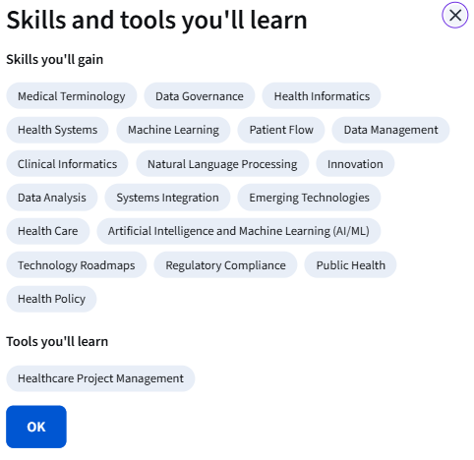

Specialization - 4 course series
The Specialization in Digital Healthcare & AI is a four-course program designed to prepare professionals to lead at the intersection of healthcare, data, and artificial intelligence. The curriculum progresses from foundational health informatics and the healthcare marketspace, through data standards and interoperability, into applied AI systems, governance, and ethics, culminating in a hands-on innovation capstone focused on safe, context-aware AI.
Learners gain a practical understanding of how healthcare data is created, standardized, exchanged, and reused; how modern AI techniques, including machine learning, NLP, generative models, and agents, are deployed responsibly; and how technical capability is translated into clinical, operational, and commercial value. Emphasis is placed on trust, explainability, regulatory alignment, and patient safety as AI becomes embedded in care delivery.
The specialization is led by internationally recognized leaders in health informatics and digital medicine, including Frank Naeymi-Rad, John Halamka, MD (President, Mayo Clinic Platform), Charles Safran, MD (Harvard Medical School, Emeritus), Evan Sholle, and Curtis Cole.
Graduates are prepared to design, evaluate, govern, and scale AI-enabled healthcare solutions, positioned to deliver value in a healthcare landscape evolving at exponential speed.
Applied Learning Project
The Capstone course is a hands-on innovation project that prepares learners to lead the responsible deployment of AI in healthcare. Students deploy large language models in a controlled, privacy-preserving environment to evaluate how trusted clinical context improves AI safety.
Learners conduct a comparative analysis of model outputs generated with and without grounded medication references, scoring performance across accuracy, completeness, and clarity. This transforms abstract concerns about hallucinations into measurable evidence aligned with real clinical expectations.
Students then translate technical findings into a defensible innovation strategy using Value Proposition, NABC, and SWOT, producing a clear business case and implementation roadmap for a context-aware healthcare AI solution.
Learners gain experience in AI evaluation, safety validation, and strategic decision-making, core skills for informatics leaders shaping the next generation of AI-enabled healthcare systems.
